**MongoDB Task**

**Database:**

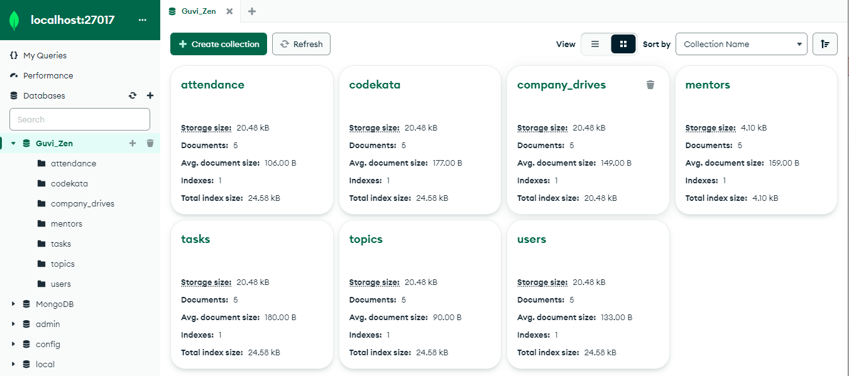

**Questions:**

1. Find all the topics and tasks which are thought in the month of October

**Tasks**

**Query**: db.tasks.find({"date":{$gte:ISODate("2020-10-01"),$lt:ISODate("2020-10-31")}});

**Output**:

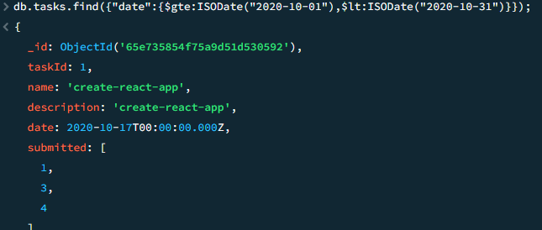

**Topics**

**Query**: db.topics.find({"date":{$gte:ISODate("2020-10-01"),$lt:ISODate("2020-10-31")}});

**Output**:

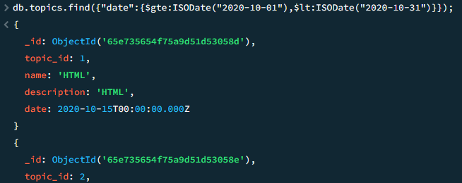

1. Find all the company drives which appeared between 15 oct-2020 and 31-oct-2020

**Query**: db.company_drives.find({"interview_date":{$gte:ISODate("2020-10-15"),$lt:ISODate("2020-10-31")}});

**Output**:

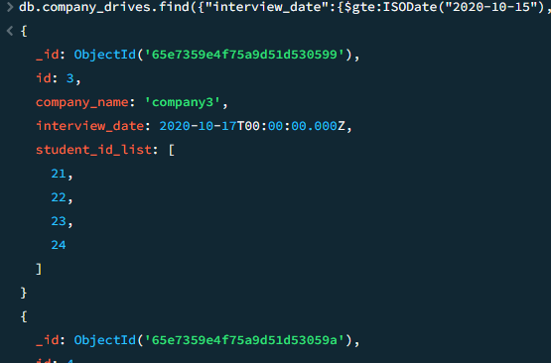

3. Find all the company drives and students who are appeared for the placement.

**Query**: db.company_drives.find({},{company_name:1,student_id_list:1,_id:0});

**Output**:

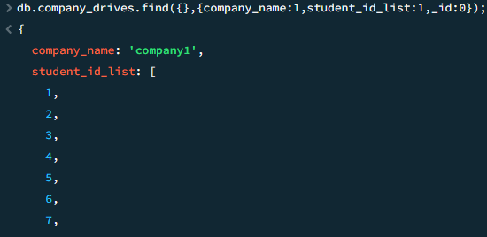

4. Find the number of problems solved by the user in codekata

**Query**: db.users.aggregate([{$project:{codekata_solved:1,userId:1,_id:0}}]);

**Output**:

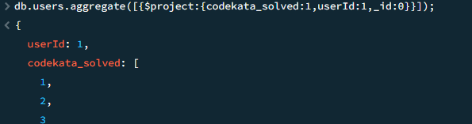

5. Find all the mentors with who has the mentee's count more than 15

**Query**: db.mentors.find({$where:"this.student_id_list.length > 15"},{mentor_id:1,_id:0});

**Output**:

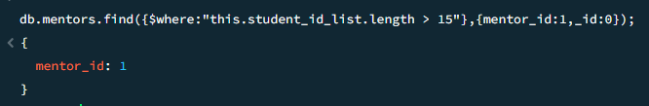

6. Find the number of users who are absent and task is not submitted between 15 oct-2020 and 31-oct-2020

**Attendance**

**Query**: db.attendance.aggregate([{$match:{"date":{$gte:ISODate("2020-10-15"),$lt:ISODate("2020-10-31")}}},{$project:{_id:0,date:1,id:1,no_of_absent: {$size: "$absent"}}}])

**Output**:

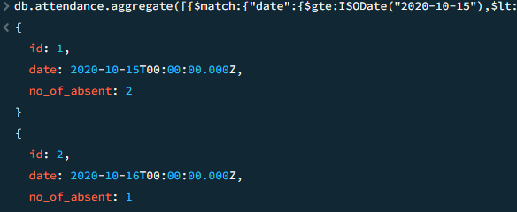

**Tasks**

**Query**: db.tasks.aggregate([{$match:{"date":{$gte:ISODate("2020-10-15"),$lt:ISODate("2020-10-31")}}},{$project:{task_not_submitted:{$size:"$not_submitted"}}}])

**Output**:

